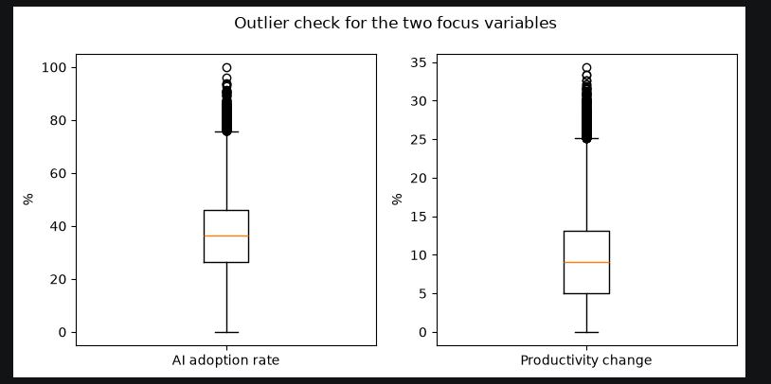
What a boxplot showsShows the 5-number summary (min, Q1, median, Q3, max) plus explicitly marks points beyond 1.5×IQR from the box — something a histogram doesn't call out directly.

One thing to check yourself before writing this into the report: your current notebook code detects these outliers (via IQR) but doesn't actually decide what to do with them — they're still sitting in df_etl_clean untouched. That's the missing piece the rubric wants explicit: you need one sentence in your report (and ideally a line in the notebook) stating that decision — e.g. "outliers were retained because they fall within valid ranges and represent genuine high-adoption/high-productivity companies relevant to the research question, rather than data errors."

1. What a boxplot shows
Shows the 5-number summary (min, Q1, median, Q3, max) plus explicitly marks points beyond 1.5×IQR from the box — something a histogram doesn't call out directly.
- Median (orange line), IQR box (25th–75th percentile), whiskers to the last non-outlier point
- Individual points beyond the whiskers = points flagged as statistical outliers
2. What these two boxplots show
Both plots show a compact, symmetric-ish middle 50% of the data, with a one-sided tail of high-value points flagged above the upper whisker on both variables.
- AI adoption rate: box roughly 26%–46%, median ~36%, whisker up to ~76%, then a cluster of dots up to ~100%
- Productivity change: box roughly 5%–13%, median ~9%, whisker up to ~25%, then a cluster of dots up to ~34%
3. What the rubric wants beyond the plot
Task 3 requires you to investigate outliers and explicitly state what you did with them (not just show the plot).
- State the count found via IQR flagging (504 for adoption rate, 529 for productivity, from the earlier cell)
- Explicitly justify the decision: retained, capped, transformed, or removed — and why
4. Is there an outlier here?
Both variables are bounded (0–100% and roughly 0–35%), so these are companies at the genuinely high end, not corrupted data.
- Yes — both variables have a cluster of points above the upper whisker (high adoption rate near 90–100%, high productivity change near 30–34%)
- None below the lower whisker — the tail is one-sided in both cases
5. Are they significant/important?
They're worth flagging in the report but arguably NOT worth removing — removing them would weaken the very relationship (adoption vs productivity) you're trying to study.
- They're plausible, not data-entry errors — both values sit within the variable's valid 0–100%/0–35% range
- They likely represent a small group of companies with near-full AI adoption and unusually strong productivity gains — worth keeping since they may be the clearest evidence for (or against) your research question, not noise to discard

